**[Shrimps Masala](https://www.facebook.com/groups/170614193063969/doc/258632774262110/)**

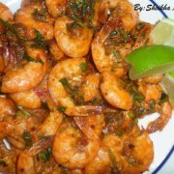

**Shrimp Masala:**

**1 lbs shrimp**

**1/4 tsp red chili powder**

**1/4 tsp dry oregano**

**1/4 tsp dry thyme**

**1/4 tsp red crushed chili flakes...**

**Marinate**

**Salt Ground pepper**

**Lemon juice**

**1/2 tsp garlic salt**

**Marinate the shrimp with all the above ingredients. Then in a pan, add some oil, 1 tbsp ketchup, 1 tbsp honey garlic sauce, 1 tsp chili garlic sauce, lemon juice, chopped coriander and the marinated shrimp and cook until well done. Taste for salt. Serve with lemon wedges. Enjoy!**